

Sourcegraph allows developers to rapidly search, write, and understand code by bringing insights from their entire codebase right into the editor

Different Products offered.

1. Cody
2. Code Search

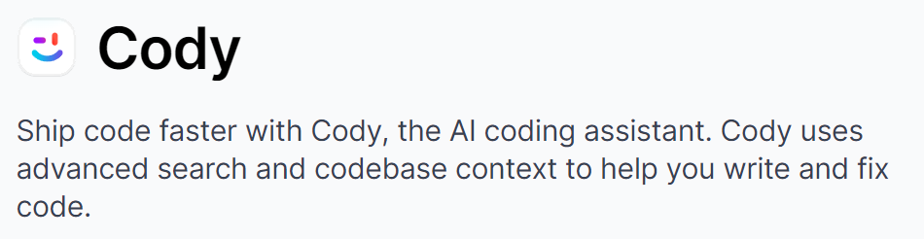

1. Faster coding with autocomplete

* Suggestions for single lines or whole functions, in any programming language, configuration file, or docs.

1. Get help with context-aware chat

* Query like a human and learn about your code, or get help with tricky problems.

1. Automate workflows with commands

* Build and personalize commands that automate common tasks. Explain code or generate unit tests in seconds.

More details from official documentation and videos

1. Use multi repo context for searching across multiple repos.
2. Document code.
3. Use to Edit code. (Also actually insert brand new code, it can generate it)
4. Generate Unit Tests
5. Find Code smells.

Version 1.28 is the latest version that has been released recently.

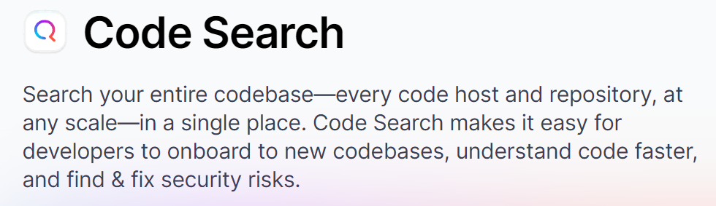

1. Find and fix code

* Find what you need in milliseconds across all of your code–no matter where it lives.

1. Track trends in your codebase

* Transform your code into a queryable database to create custom dashboards in seconds.

1. Automate large-scale code changes

* Find and make changes across your codebase in one go, whether a version change or a vulnerability fix.

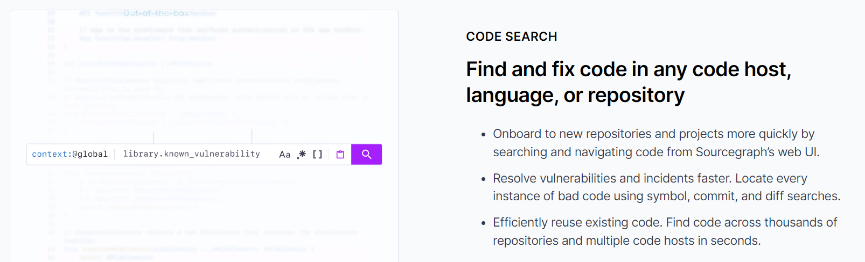

More details from official documentation and videos

1. Code Intelligence – You can search for a keyword and see where it is defined, where it is referenced etc.
2. This in turn has two types of search intelligence – Precise and search-based code intelligence.
3. Search by Type – Like Code, Repositories, Paths, Symbols, Commits and Diffs